***TECHNOLOGICAL PROCESS OF APPLE TREE GROWING***

Fruit growing has old traditions in Latvia and the climatic conditions and soil are favorable for it, especially in the eastern regions of Latvia. Our fruits and berries may contain somewhat less sugar than the varieties grown in the south, yet they have more aroma and organic acids, and significantly less pesticide sprayings are needed for their growing. **Apples** are by far the most widely grown fruit crop in all types of orchards in Latvia.

One of the most significant conditions is to choose an appropriate place for apple tree growing. If the garden is planted in a suitable location both in terms of soil and terrain, varieties and rootstocks have been chosen properly, the fruit trees and bushes grow well, they are more resistant to harmful organisms, the need to use chemicals will significantly decrease, and thus protecting environment.

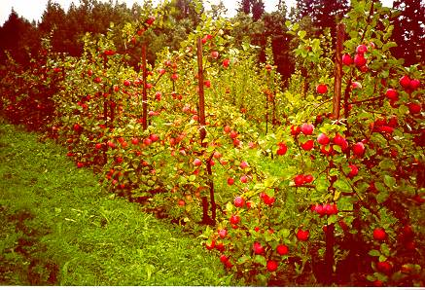

The most suitable place for apple tree growing is the one that is higher than the surrounding areas, allowing cold air to flow away and thus not affecting a garden. Garden cannot be planted in areas with difficult air circulation, poor drained, water-tight soils.

In places where the soil is heavily contaminated with the larvae of pests, soil fungi etc. you cannot plant crops that are sensitive against them. The soil mustn`t be disinfected with chemicals.

Soil sanitation plants are green manure that has to be worked into the soil, they are oilseed radish, white mustard, brassica etc.

**INFLUENCE OF RELIEF ON FRUIT TREE WINTER HARDINESS**

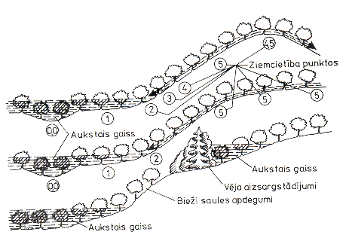

AUKSTAIS GAISS – COLD AIR

BIEŽI SAULES APDEGUMI - - OFTEN GETS SUNBURNT

VĒJA AIZSARGSTĀDĪJUMI - PROTECTIVE PLANTATION

ZIEMCIETĪBA PUNKTOS - WINTER HARDINESS IN POINTS

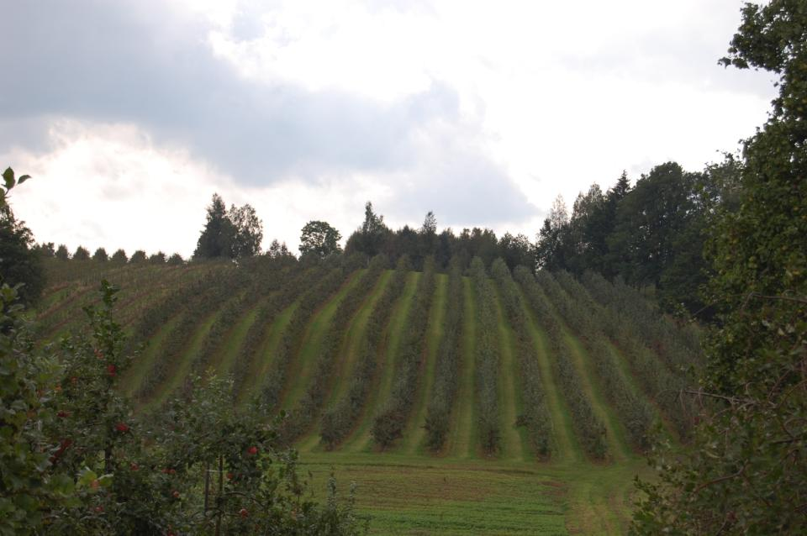

In Latvian conditions where the limiting factor is sunlight, excessive thickening of planting is not recommended. But too sparse plantation prevents rational use of land, as well as increases the cost of maintaining the garden.

H

A

**H = A : 2 + 1m or A = (H – 1m) × 2**

The optimal tree height (H) is calculated by dividing the distance between the rows (A) by two and adding one more meter.

Apple trees whose height is about 2.5 – 3 meters should be planted about 4 meters apart from each other.

In order to use the sunlight in the best possible way, apple trees should be planted in the direction south – north.

**Maintenance of environmental diversity in the garden and in its vicinity, and reduction of pollution**

* Protective plantation is important in helping to reduce the speed of wind; to reduce destructive effects caused by cold air masses;
* Protective plantations also preserve environmental diversity and beneficial organisms.

Taking care of beds and spaces between rows is an important factor in apple tree growing. Grass is sown regularly about 5-6 times during vegetation period, the cut grass has to be left on the ground.

**Pruning principles for pome fruit**

Why should apple trees (pome fruit) be pruned? What is its aim?

The aims can be different**.**

* First of all it is important to have an early harvest;
* The harvest has to be good not only in the first year but also in the following years;
* Thirdly the harvesting process should be pleasant and the shape of the tree greatly facilitates the process.

Crown must be sufficiently sparse and narrow to provide light and the access of plant protection to all areas evenly. The gardens where apple trees have such crowns the consumption of plant protection products is lower and better targeted, and more environmentally friendly.  
Tree height should be limited, depending on the planting distance. They must not shade each other. Efforts should be made to strike a balance between growth and production.

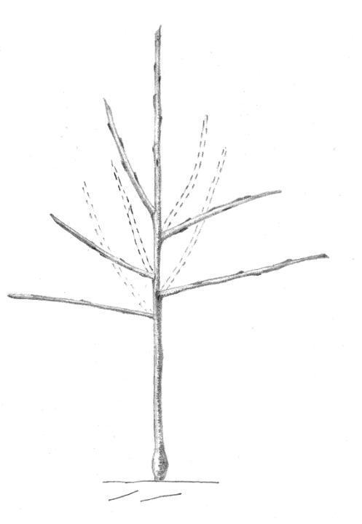

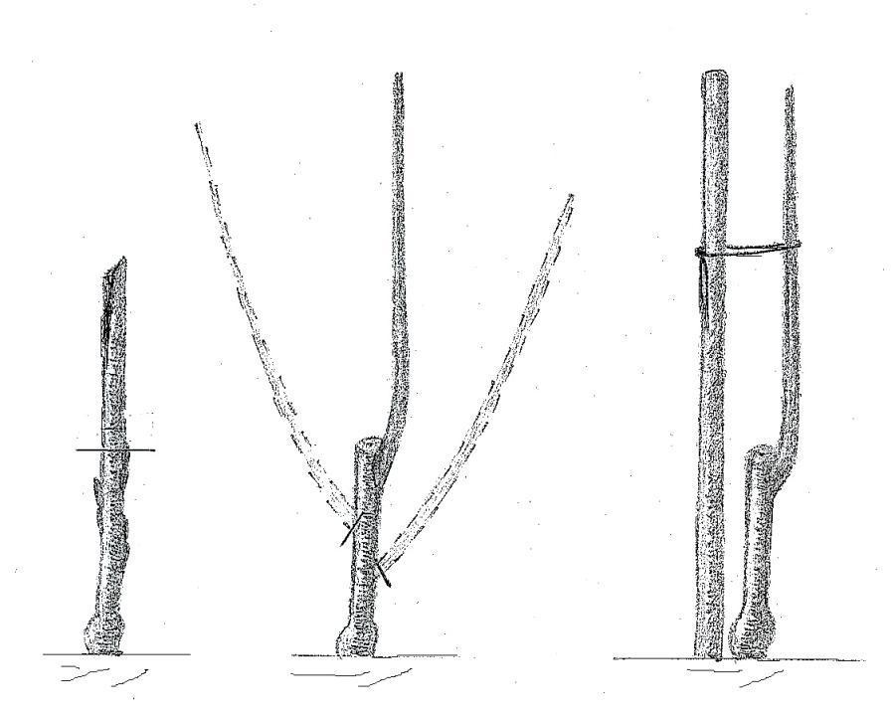

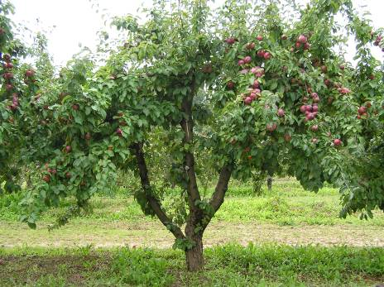

When bending branches of fruit trees the following should be noted:  
- the angle of fruit tree branch bending can be different - the closer they are planted the more you should bent the branches;  
- the higher the branches the more you have to bend them;  
- new apple and sweet cherry tree branches have to be bent in the second half of summer.

